CS6051 Artificial Intelligence and Machine Learning
Assignment 2: Knowledge-based Problem Solving
- Problem definition
Given the maze on Fig. 1 (5 x 6 nodes) represent the knowledge and find a path between the starting node (0.0) and the end node (4,5) using logical infrenece. The permitted moves are four: Left, Right, Up and Down, the red nodes contain obstacles and no movements in them are possible through them. The boundaries are walls which are blocking the movements.
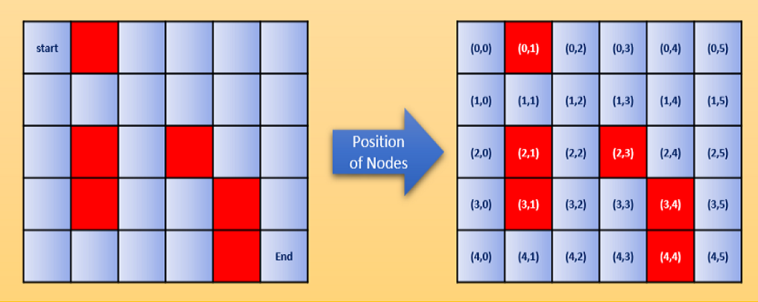
Fig. 1 The Maze Problem
- Problem Solution
A logical theory and a Python program which finds the path from the start node to the end node of the maze using knowledge base containing representation of the knowledge and applying logical inference. The code of the program must be submitted to WebLearn by the deadline and will be demonstrated during the next seminar.
- Marking
Basic tasks max 48 marks
- Specify the facts for modeling the maze using FOL in the format of ground formulas
- Formulate heuristics using FOL in the format of rules with universally quantified variables
- Chose suitable method for logical inference and suitable inference rule (s) for automation
of the inference in the logical theory of FOL
- Formulate the success criteria for solving the problem as a goal statements and the starting
position in FOL in the format of ground formulas
- Demonstrate logical inference in the logical theory using the chosen inference
method and rules of inference to find the solution
- Chose suitable data structures for representing the logical formulas specified in the
logical theory and create a Knowledge Base with facts and rules representing it in Python
- Specify an algorithm for unification of formulas and program it in Python
- Run the program and display the result of its execution
Additional tasks max 36 marks
- Implement an alternative solution of the problem using different method and rule(s) of inference in the logical theory
- Implement an alternative solution of the problem using different method and rule(s) of inference in Python
- Trace the execution of the Python program to show the attempted nodes during the inference process
- Visualize the paths from the starting position to the goal position in the Knowledge Base during
execution of the program
Written Report max 16 marks
Total max 100 marks

- Deliverables
You need to submit 3 files by the deadline:
- A written report presenting the logical theory for describing the problem and the logical inference showing the process of solving it (pdf)
- A written report describing the program which implements the theory (pdf)
- An archive file containing the Python code in zip format (zip)

Notes:
- The basic tasks are scored max 48% which means that in order to pass it is necessary to have a report as well (min 50% for pass)
- The additional tasks are scored max 36% to allow earning higher scope (min 70% needed for excellent)
- The demonstration is not marked but without demonstration the Python tasks will be discarded, which means that the overall score cannot be first class (min 70% needed for excellent)
- The report is marked up to 16 % but without report the logical tasks are discarded, which means that the overall score will be not very good (max 54%)

